10. Write detailed scenarios for your project:

Scenario for the online exam system:

Initial assumption:

The student has seen the teacher or the responsible who created the exam in the system and collected the students’ personal information (name ,email ,password ,,etc).

The teacher or who is responsible will log in the system and seeing the grades or the students’ mistakes.

Normal:

The teacher will search to the students’ name to see what he done in his exam.

What can go wrong:

The students’ record does it exist or cannot be found .

Other activities:

The exam may be consulted but not edited by other staff while information being entered.

System state on competition:

User is logged on. The student information with his exam result history is entered in the database . The grades are added to the system log showing the start and the end time of the session and the nurse involved.

11. Draw use cases diagram for all use cases of your project like in chapter 4 page 65 (a professional drawing software is a must like a Microsoft Visio, or Microsoft office):



12. Draw full details context UML diagram of your project like in chapter 5 page 10:

Administrator system

Management reporting system

The online exam system

v

Teacher system

v

Student’s marks system

v

13. Draw fully detailed process model UML diagram of your project like in chapter 5 page 12 :



System admissions system

Record the student info

Transfer to secure exam

Admit to exam system

Update register

İnform next of kin

İnform social care

Online exam system

Transfer to police station

Find secure place

Online exam system

İnform the student

Confirm exam decision

14. Draw every use cases UML diagram of your project like in chapter 5 page 15:

1 1

Student student record

15. Prepare tabular description of your projects’ use cases like in chapter 5 page 16:

Table for transfer data:

|  |  |
| --- | --- |
|  |  |
| actors | The teacher, or who responsible for the exam’s system. |
| descriptıons | The student will sign to his exam by writing his personal information or if he is new just he need to make a new account . |
| data | Student’s grade and his answers. |
| stimulus | User command issued by the online exam system. |
| response  comments | Confirmation that the exams and the grades are updated.  The teacher must have appropriate security permissions to access the students’ information. |

16. Draw use cases of each agents’ use cases UML diagrams of your application like in chapter 5 page 17:



administrator

17. Draw Sequence diagrams of every action in your project like in chapter 5 page 19-20:

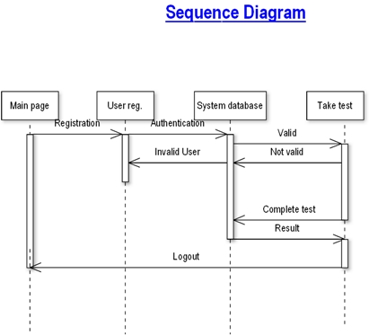

18. Draw UML classes associations of all classes like shown in chapter 5 page 23-24:

A use case in the online exam:

 the exam system The teacher

19. Draw class models like shown in chapter 5 page 25:

